**Software Requirements Specification**

**for**

**Task Management System**

**Admin control panel and mob app**

**Version 1.0**

**Prepared by**

Name

[name@company.com](mailto:name@company.com)

0100125214866

**Date: May 8,2021**

# **Contents**

**REVISIONS ............................................................................................................................................................................**

1. Introduction 3

* DOCUMENT PURPOSE 3
* PRODUCT SCOPE 4
* INTENDED AUDIENCE AND DOCUMENT OVERVIEW 4
* DEFINITIONS, ACRONYMS AND ABBREVIATIONS 5
* REFERENCES AND ACKNOWLEDGMENTS 5

2. Overall Description 6

* PRODUCT PERSPECTIVE 6
* PRODUCT FUNCTIONALITY 7
* USERS AND CHARACTERISTICS 8
* DESIGN AND IMPLEMENTATION CONSTRAINTS. 9
* USER DOCUMENTATION 9

3. Specific Requirements 10

* EXTERNAL INTERFACE REQUIREMENTS 10
* FUNCTIONAL REQUIREMENTS 12
* IllUSTRATIVE DIAGRAMS…...………………………………………………………………………15

4. Other Non-Functional Requirements 16

* PERFORMANCE REQUIREMENTS 16
* SAFETY AND SECURITY REQUIREMENTS 16
* SOFTWARE QUALITY ATTRIBUTES 16

# Revisions

|  |  |  |  |
| --- | --- | --- | --- |
| **Version** | **Primary Author(s)** | **Description of Version** | **Date Completed** |
| 1.0 | name | This is the first version of this document | 8/05/2021 |

**1 Introduction**

This Software Requirements Specification (SRS) document is to produce a comprehensive description of all software required to complete the project.

The SRS is split into subsections in which each presents a different topic to be discussed.

Section 1 contains an overview of the whole system, what purpose the project will have, what will be targeted specifically for the SRS , and the references, are all the resources that were mentioned throughout the SRS document.

Section 2 contains the modeling of our system so that when it is implemented, it will show how all of our classes will behave, show how the functionality will perform in the viewpoint of the users, depicts how the system will behave, what dependencies the system will have, and will also explain the criteria that show that all goals have been met.

Section 3 gives the specific requirements for how our system is expected to behave and how that behavior meets all the project goals.

Section 4 indicates the non functional requirements that the sw product need to work in a perfect way.

**1.1 Document Purpose**

This document is intended to present the requirements of the system to be produced, both functional and non-functional. The specifications contained in this document will be used to support the production of the system in later stages, in an attempt to reduce the development effort involved. The SRS explains the current system being used by the customer, the reason for the creation of the new system and a broad overview of the proposed system to be developed. It also serves as a contract between the customer and the supplier to approve the requirements contained here, as specified in the acceptance criteria. The audience of this document (Software Requirements Specification) primarily includes the Project Team, the Client and the Project Supervisor.

**1.2 Product Scope**

The main function of the software will be to provide quick and easy access for administrator and employee for overseeing tasks.

The control panel will be therefore designed to allow admin to perform the following functions:

Log in / view history of previous tasks assigned or completed / view and

manage employees / view,manage,keep track tasks and its status / create

employees and tasks reports / track the performance of employees with

analytics.

The mobile app will be designed for employees to perform the following functions:

Log in by ID and password, according to their type there will be different

privilege / receive task, work on it, and chat with other paticipators in project /

submit task and it will be automatically sent to next position according to

position hierarchy / track its tasks and change its status.

**1.3 Intended Audience and Document Overview**

Task Management 1.0 SRS is derived from communication between the authors, and their product customers. Therefore, our intended audience consists of the business owner. the IT support department. the employees responsible of mananging projects inside company. team leaders of analysis, design, development and testing teams

**1.4 Definitions, Acronyms and Abbreviations**

API - Application Programming interface

GUI - Graphical User Interface

SQL - Structured Query Language

Customer : The client of the system

Project : The name used for assignments leaders give to their employees (Contrast with ‘Project’). This term is also used in this document to refer to the system that we are developing.

Task : A function to be performed by employees. Tasks are created by the leader, and comprise one of the following sub-modules: Brainstorm, Signup, Schedule, Submit or Assessment.

Topic : The subject of the project selected by leader.

User : Those people who will be using the ‘Project’ module. This may be, but is not limited to, our client. Like administrators for control panel & employees for mobile app.

Control panel (dashboard) : tool that provides a centralized, interactive means of monitoring, measuring, analyzing, and extracting relevant business insights from different datasets.

**1.5 References and Acknowledgments**

At this time this SRS does not reference any outside resources.

**2 Overall Description**

**2.1 Product Perspective**

Task Management System (TMS) is a web application by which company can manage tasks among its employees. The task management system is an automated support tool to be used by administrative staff of various departments. Currently all work tasks requests are handled manually. The task management system automates the process by streamlining the handling of the work tasks requests thereby reducing the manual intervention. This project has various small parts like commenting on task, upload and download files, task forwarding, editing existing and creating new project, task, employee, user etc . TMS is an automation system, which is used to store the Work tasks information of a company. The task management system eliminates manual request and assignment of work. Employees can receive any work tasks online through mob app. When a company member places a work tasks, administrative staff receives the work tasks. The work order will include all necessary information including the availability schedule of the company member. Administrative staff review the incoming work tasks and assign them to appropriate personnel. When the work task gets done, the personnel that finished it will update the status of the work task to complete. Both the company and administrative staff will have various reports available to view the pending/completed work tasks, the average processing time of the work tasks and so on. Development process of the system starts with System analysis. System analysis involves creating a formal model of the problem to be solved by understanding requirements.

**2.2 Product Functionality**

There are two types of users, named Admin and Employee. Admin for control panel to control process of managing tasks between employees and Employee for mob app to do these tasks.

All types of employees must log in by user ID and password. According to their position there will be different privilege.

Every project has some number of tasks and employees. All tasks under a project can only be handled by these employees.

A task is assigned to only one employee at a time. Task can be forwarded to other employee of that project.

An Admin user has some extra privilege including all privilege of an employee.

Admin can create project, edit project information, add / remove employee to a project and can close a project.

Admin can track multiple projects.The Project list can be customized to list current Projects, finished Projects or all the projects to keeps you up-to-date with the project status in progress bar.

Admin can create task, edit task information and close task.

Admin can create employee, edit employee information.

Admin can set employee depatement and position.

Admin can view project, task , task history, employee reports

An employee can verify his project status, comment on his task, attach file with task, forward the task to other employee of its project and also can download attachment of his task using mob app.

**While creating a project Admin will be a member of the project by default.

**A project can only be closed if its entire tasks are closed

**2.3 Users and Characteristics**

**Adminstrator** : Adminstrator is also called project manager of the company. He can have all the privileges to do anything in this system. Administrator can register new employees, clients, projects which are coming into the organization. Admin can keep track team employees and their performance. Administrator is a super user treated as owner of this site, Basic and advanced admin facilities like add, delete, update, backup, recovery of data, and generating various kinds of reports.

Administrator can add new policies, information, notices and their work structure into the system. If a new policy is added into the system, the information of that policy and catalog, search facility for available policies exportable in PDF format to customer. Admin can provide on line help to the customers and process their queries and send status to the customers.

**Departement Boss** : one who oversees staff and assign duties to his employees.

**Employees** : co-workers who can perform the tasks delegated to them by the depatement manager.

**2.4 Design and Implementation Constraints**

The system makes the overall project management much easier and flexible.

User Friendliness is provided in the application with various controls provided by system Rich User Interface.

The system must be programed in an object-oriented language, in this case we will be using C#. The SQL database must be attached to the system.

The system must use an internet connection or the user will not be able to communicate with the database.

The user information can be stored in centralized database which can be maintained by the system.This can give the good security for user information because data is not in client machine.

Authentication is provided for this application only registered Users can access.

There is no risk of data management at any level while the project development is under process.

Categorization of computers in the database make easy to identify the various computer peripherals.

The Task Management System must be portable so that multiple computers may be used to look at the information.

At this time, testing has not been done on versions earlier than Windows 8.

**2.5 User Documentation**

There should be minimal help needed to run this system. Should there be a need for help, there will be a help menu that will guide the user through using the system. This document will also serve as for all help documentation that follows.

**3 Specific Requirements**

**3.1 External Interface Requirements**

3.1.1 User Interfaces

* Dashboard

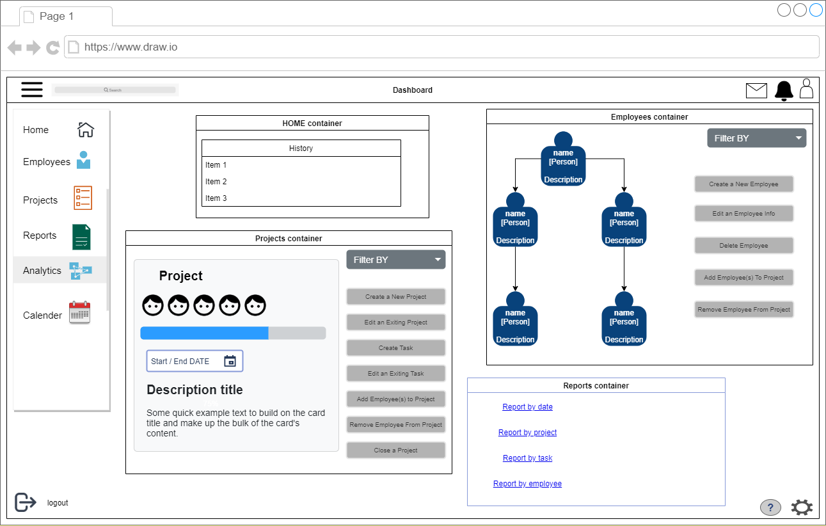

* Mobile App

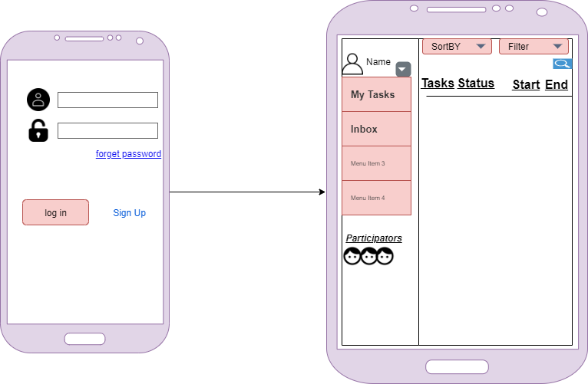

3.1.2 Software Interfaces

The Task Management System will be using a C# API to communicate to the server, which will allow access to the SQL database.

**3.2 Functional Requirements**

* Dashboard

3.2.1 Log In page :

Admin must login by his user name and password. After clicking on Log in button codes behind the page will call a method of UserManager class,CheckUserIdAndPassword(userID,password), which takes user ID and password as parameter check it with database if any match found, admin can access dashboard. If no match found this method will return empty string and which conclude as wrong password. Code also adds a session variable which is user id.

3.2.2 Admin Home page :

In this page, Admin can see the history of his actions and filter it according to different parameters.

3.2.3 Projects page :

In this page, Admin can access all projects and its information , mange projects and its tasks and send tasks to employees

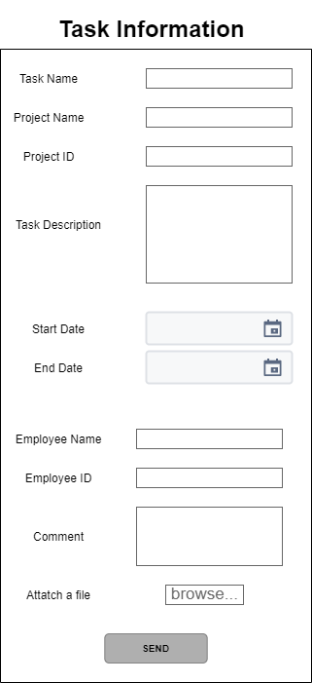

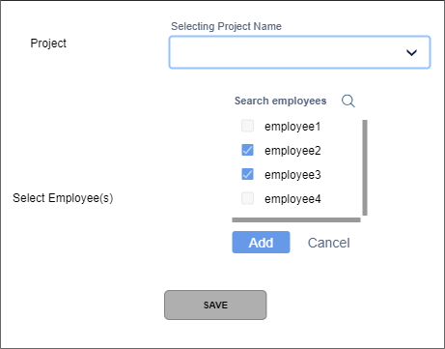

3.2.4 Employees page :

In this page, Admin can build the structure hierarchy of company and manage it so the task can automatic sent to the correct employee after employee submit it, mange employees information and assign tasks to them.

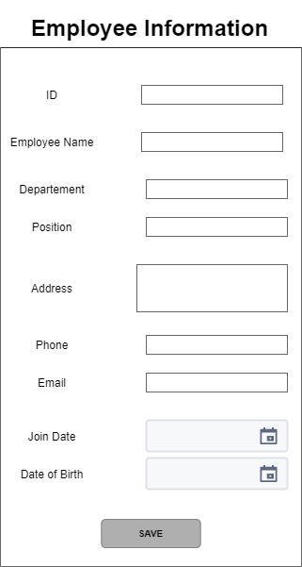

3.2.5 Reports page :

In this page, Admin can generate various kinds of reports.

3.2.6 Analytics page :

In this page, Admin can track the performance of employees and progress of projects using chats and visual shapes.

* Mobile App

3.2.7 Log In page :

In this page, Employee can log in with his ID and password. If he forgot one of them, he can retrieve it through email or mohile number.

3.2.8 Tasks page :

In this page, Employee can see all his tasks with its time duration , open task, download it with its attachements, work on it, change its status and submit it when finished.

3.2.9 Inbox page :

In this page, Employee can chat with other employees in same project and exchange resources that help them fishining their tasks.

**3.3 Illustrative Diagrams**

* CLASS DIAGRAM
* 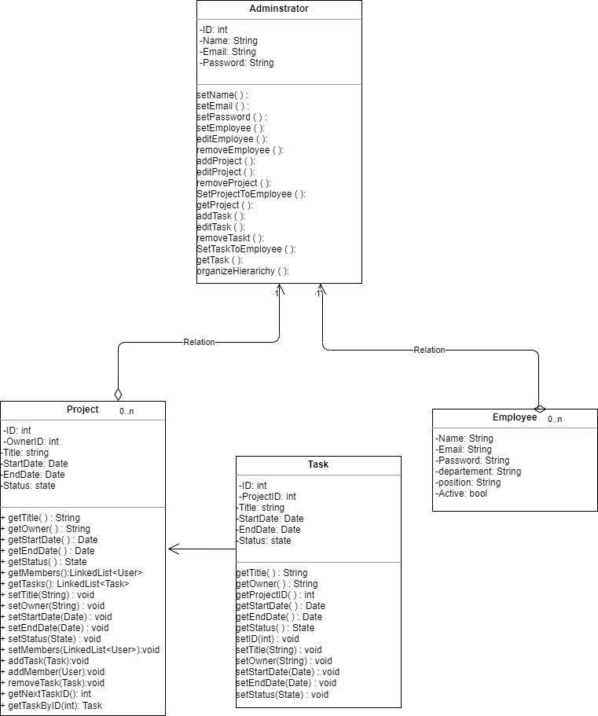Dashboard Mobile app

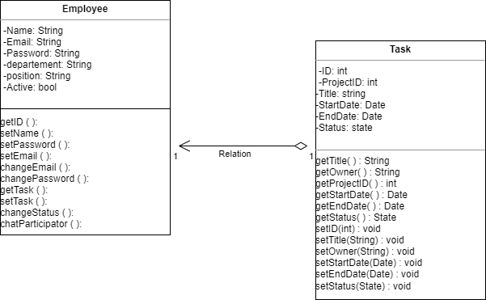

**Other Non-Functional Requirements**

**4.1 Performance Requirements**

The system shall perform basic operations in less than 2 seconds. While navigating the system, user interfaces should update quickly, this is not an issue and doesn’t need to be addressed. The system shall run on different browsers and different OS.

**4.2 Safety and Security Requirements**

User account names will be associated with a password which will be chosen by the user upon first use.

Admin password will be associated with one secret question to assist in password reset.

Employee password reset will be performed by the admin

If the admin / employee enters an incorrect password 3 times, they will be locked out

**4.3 Software Quality Attributes**

**4.3.1 Usability**

The interfaces of the system will be designed in a user-friendly manner such that the user will need no training to perform operations within the system. The interfaces will be easily navigable, clearly labeled, and a help menu will be provided with instructions for performing basic tasks.

**4.3.2 Maintainability**

The system code should be written to allow for future possible upgrades. Code will be documented, including version updates and authors. Code will be fully commented. Each method will include a description of its function and any additional information needed to help in future additions.